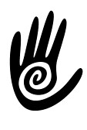

RIO MASSAGE & WELLNESS
RioFlagMassage.com

CLEANING PROTOCOLS

Therapist will:
- Clean bathroom touched surfaces after every client use
- Disinfect hard surfaces between clients
- Disinfect commonly touched surfaces between each client (ie doorknobs, counters, light switches, phone, and any other surfaces touched by either client or therapist during session)
- Vacuum with a HEPA filter, daily
- Ventilate room between clients and use an ozone air purifier between sessions
- Deeper cleaning of bathroom at end of each day

